Compare and Contrast Lesson Plan

*Lesson Plan for Grade 4, Social Studies and Reading*

# OVERVIEW & PURPOSE

The purpose of this lesson is to compare and contrast the difference between the Idaho Cut and another of Quincy’s cuts, the Daisy Cut. This will help cement the idea of what a facet is.

EDUCATION STANDARDS

1. [L.4.6](https://learning.ccsso.org/wp-content/uploads/2022/11/ELA_Standards1.pdf)

Acquire and use accurately grade-appropriate general academic and domain specific words and phrases, including those that signal precise actions, emotions or states of being and that are basic to a particular topic.

1. [4.SS.4.2.1](https://www.sde.idaho.gov/academic/shared/social-studies/ICS-Social-Studies.pdf)

Explain the significance of Idaho symbols and the unique tribal seal of each federally recognized tribe in Idaho.

OBJECTIVES

1. Students will be able to compare and contrast a gem with a facet
2. Students will better understand what a facet and gem are.

MATERIALS NEEDED

1. Pencil/pen
2. Compare and Contrast sheet (provided below)
3. Overhead projector or whiteboard to go over the first example as a class.

ACTIVITY

Work as a class to fill out the first Venn Diagram about the Idaho Cut vs. the Daisy Cut (two different facets of gems) and then have students work in groups to figure out the differences between a gem and a facet.

Compare and Contrast

Idaho Cut vs. Daisy Cut

|  |  |
| --- | --- |
| The Idaho Cut was created by Quincy D. Howell in 1977. It has 32 identical facets in the bottom (the pavilion) positioned to come together to a single point. | The Daisy Cut was created by Quincy D. Howell in 1977. It has a distinctive pattern in the bottom (the pavilion) that appears to be a daisy when viewed through the top (the table). |

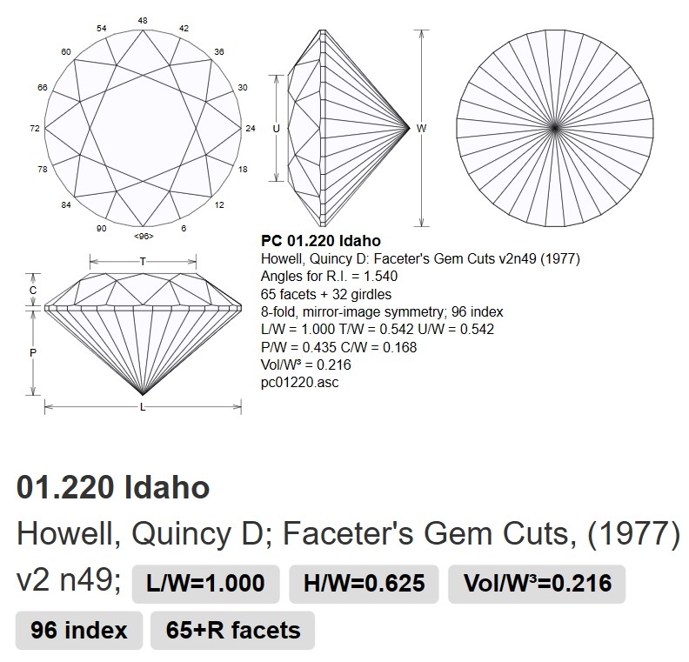 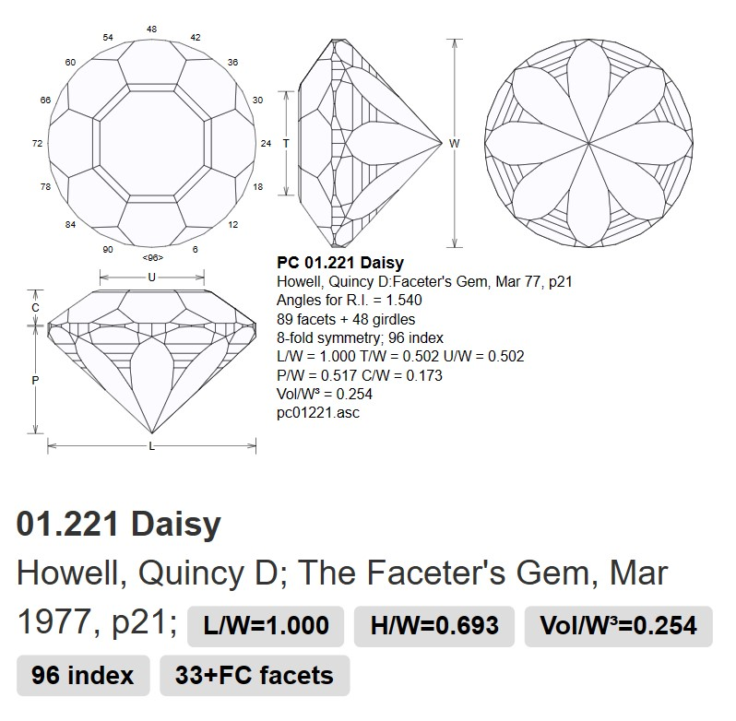

Compare and Contrast

(Teacher Key)

Idaho Cut vs. Daisy Cut

Ex:

* Octagon and triangles cut in top
* Looks like a star from the top

Ex:

* Hexagons cut in top
* Looks like a daisy from the top

Ex:

* Both are cut into stone
* Both created by Quincy D. Howell
* Both created in 1977

Compare and Contrast

Gem vs. Facet

