Find the Missing Angle-Idaho Cut Worksheet

Use a protractor to measure the angle to find how big the angle is.

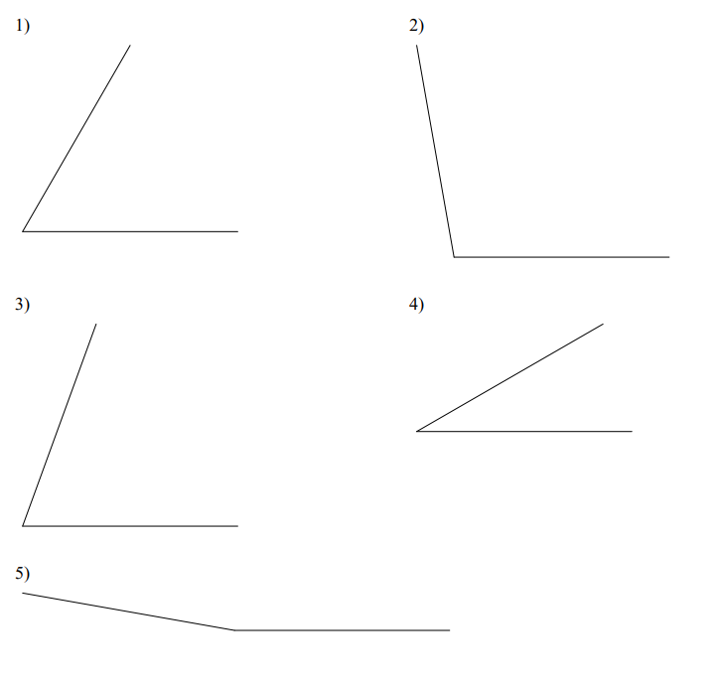

Find the measure of the missing angles.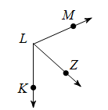

6. **∠**MLZ=66°

**∠**MLK=114°

**∠**ZLK=_______

7. **∠**ABC = 172°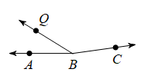

**∠**QBC = 140°

**∠**ABQ = _______

Below is a top view of the Idaho Cut. Use what you’ve learned about measuring angles and solving for angles to find the angles that are in the Idaho Cut.

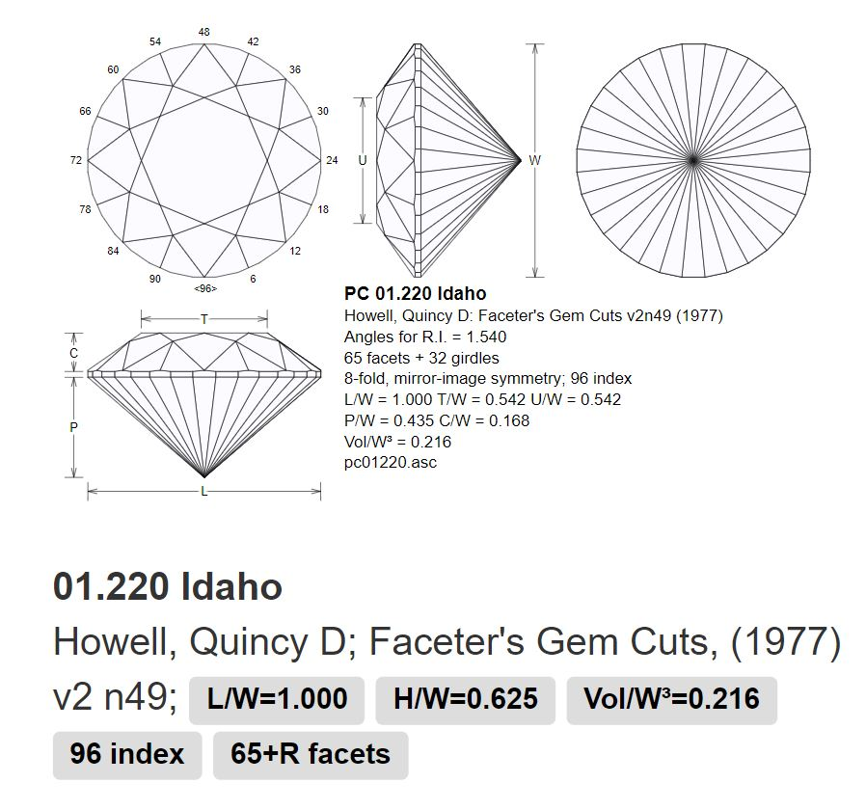

Find the Missing Angle-Idaho Cut Worksheet KEY

Use a protractor to measure the angle to find how big the angle is.

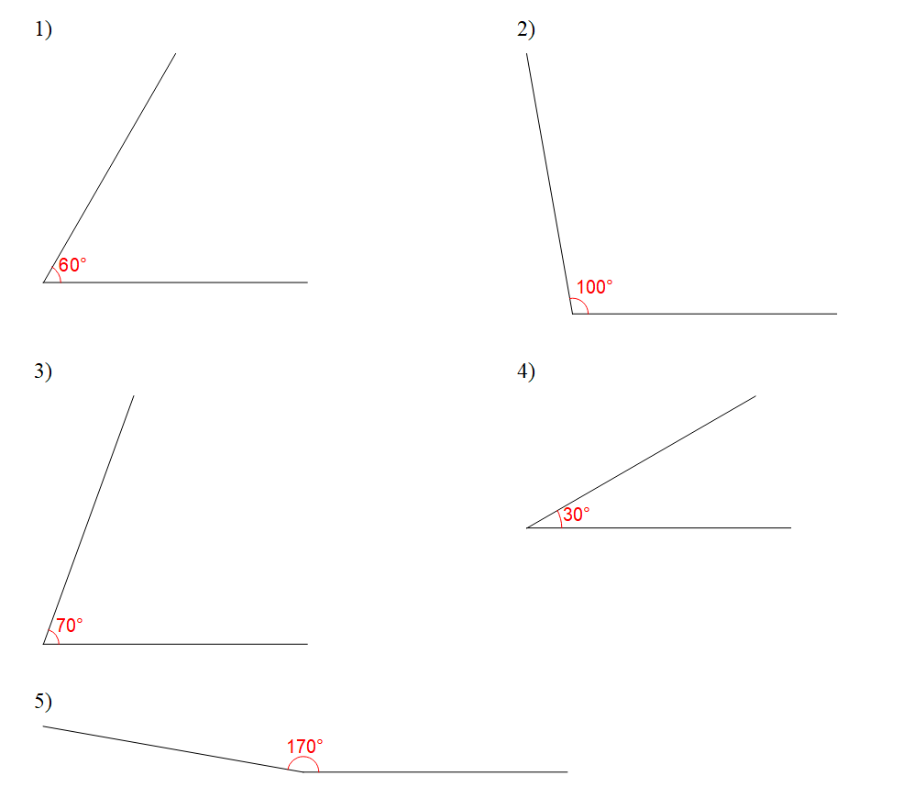

Find the measure of the missing angles.

6. **∠**MLZ=66°

**∠**MLK=114°

**∠**ZLK=__48°__

**7. ∠**ABC = 172°

**∠**QBC = 140°

**∠**ABQ = __32°__

Below is a top view of the Idaho Cut. Use what you’ve learned about measuring angles and solving for angles to find the angles that are in the Idaho Cut.

